Elite Dance Academy of Marlboro Commemorative Recital T-Shirt
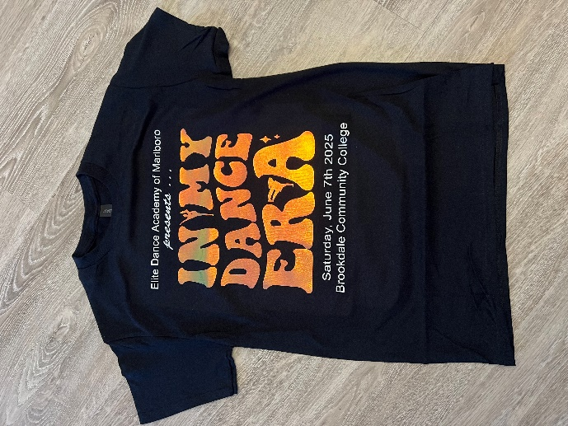
This T-shirt has a holographic design which changes colors as you move! Please fill out the order form and return it by
Saturday, February 22nd.
Price per shirt: $22.00.

Student Name: ____________________________________________________________________

Parent Name: _____________________________________________________________________

Email: _____________________________________________________________________________

Shirt Size & Quantity:

3T_____ 4T_____ CXS _____ CS _______CM _____CL _____ CXL _____

AS _____AM _____AL _____AXL _____ AXXL _______ AXXXL ______
Personalization on the back of the shirt? (Each personalization is an additional $3.00):
Some fun ideas for personalization are Julia’s Mom, Hallie’s #1 Fan, Ella’s Best Friend or Hannah’s Sister!!
__________________________________________________________________________________________
Office Use Only
Amount Paid: ______________ Personalization Checked by: _________

CASH (CASH RECEIPT # ________) CHECK #________ VISA MASTERCARD DISCOVER AMEX ZELLE. VENMO

